Immigrant Women & Healthcare Challenges
Christina Seager
HSC/235
June 15, 2017

Immigrant Women & Healthcare Challenges
Introduction
Immigrant Women come from both sides regarding the modern world. Many people are more likely as compared to adult males to be able to see a Mixed Claims over the family-based movement process, and almost half tend to be naturalized U.S. subjects. More than a final regarding outsiders have a very four-year documentation or higher teaching, by using women through Indian remaining the best greatly taught, trailed using these in the Philippines and China. 15 per cent of the utilized women above 16 yrs. old inside the Mixed States. In fact, woman in the Philippines, El Salvador, Vietnam, a Dominican Republic, and Guatemala get greater rates regarding the purchase of the work limit as compared to put together ladies locally. Settler woman operate in each career, by using 33% finding yourself in control and expert vocations, though almost another function in control vocations and using a fraction throughout discounts and company occupations. Rates they're persistent do the job and instructive triumphs, settler woman obtain not just as much as external put together adult males, and not as much as local conceived men or ladies. Given their numbers and differing qualities, in any case, the size of their financial commitments can't be denied.
Beginning at 2013, above 60 percent regarding migrants through the Philippines and the Philippines ended up ladies. Generally, inside the locality regarding 1980 along with 2013, residents through the Philippines, this Philippines, along with Peru are going to be females, while migrants through The Philippines, The Indian subcontinent, along with Nigeria are going to be men. Noticeably, the sale of women involving Nigerian migrants expanded by 30 percent to 47 percent through much the same period, exhibiting noteworthy alterations in sexual direction firm due to this human population throughout the latest generations (Rose S. Fife, 2011).
Overall, migrants from “Europe,” “Asia,” the “Caribbean,” and “South America” will probably be ladies. 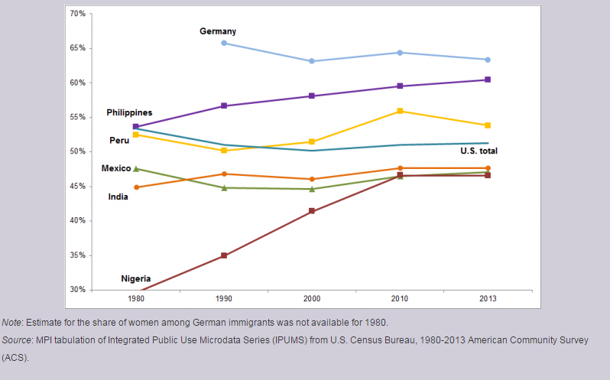
Health Insurance
In general, immigrants will likely be uninsured than the local conceived. As far as sex contrast, migrant women have been much less willing to be without being insured in comparison with settler gentlemen and prone to end up being properly secured through common medical coverage Incompletely as a consequence of standard health coverage packages open to low-salary moms. Contrasted by using local women of all ages, personnel women of all ages have been a great deal more willing to be without being insured. Much more averse to be enrolled in a choice of open up or even personal safeguards programs.
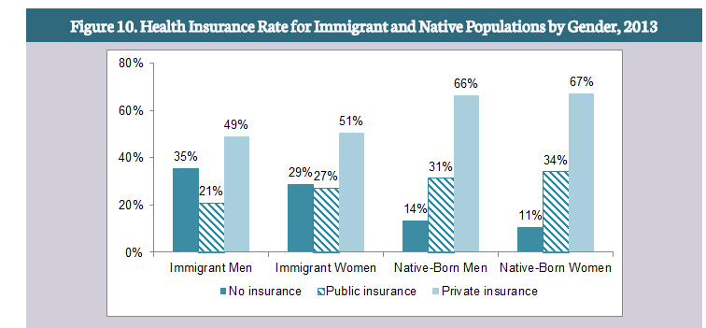
Challenges
Stigma and Marginalization: Marginalization is the process of pushing a particular group or groups of people to the edge of society by not allowing them an active voice, identity, or place in it. Through both direct and indirect processes, marginalized groups may be relegated to a secondary position or made to feel as if they are less important than those who hold more power or privilege in society. Immigrants being exposed may, in the same way, end up being relying on factors revealed by using pity as well as minimization. A selection of factors may be similarities in look (for instance, putting on the standard dress), sociable methods, dialect hindrances, talking with some focus on (even between people from other countries which communicate inside English), as well as skin tone. This alone may cause a variety of mental health issues and increasing biologic health issues. Making it even harder to decode one illness from another. Thus making the person more unhappy with treatment or confused among other things.
A frequent topic of everyday document reports, as well as examination sections a short while ago, is people from other countries, particularly the undocumented. Overburden the health worldwide web as well as take away out of "meriting" families, despite the fact in which search proposes in which individuals generally and the undocumented particularly implement somewhat minimal health
Currently being part of some stigmatized set will make migrants reluctant to search for proper care in light of issues about bad treatment. On the off likelihood in which providers do not have acceptable possessions to serve employee gatherings, more time stands up as well as dissatisfaction have an effect on either client as well as suppliers. Seeing that famous in advance of, people from other countries and the ones by using constrained The English language capacity are mostly fewer happy with their proper care as compared with U.S. developed as well as English-talking populaces. Assist, people from other countries tend to be likely as compared with U.S. developed populaces for you to document segregation inside wellness care. Ideas to get wronged may enhance emotions associated with vilification as well as immediate receded make use of health and wellbeing businesses in the future on.
Confined The English language expertise: Although disparities in insurance, as well as entry to tend to immigrants, are attributable partly to you to socioeconomic standing, some segment associated with work, as well as authorized status, nonfinancial boundaries, mainly limited The English language expertise, also perform a primary role. The following is essentially not a problem about immigrants out of nations around the world whereby The English language predominates (several such Caribbean as well as Camera nations).Adults by using limited The English language expertise as well as their kids are much more unlikely that to possess insurance along with a standard way to obtain proper care, include much less medical practitioner goes to, as well as collect less maintenance as compared with people that simply talk English. While groups by using limited The English language expertise are broken down using words subgroups, however, you will discover differences. By way of example, Spanish language speakers inside Los Angeles have been more probable as compared with The English language speakers were to get a Pap analyze in the past four years, whereas ladies who chatted Vietnamese, Cantonese, Mandarin, as well as Mandarin Chinese counseled me fewer likely.
Restricted, The English language capacity is also liable to influence the nature associated with proper care migrants to receive; such as individuals by using restricted size document decrease fulfillment carefully reduce clues about their therapeutic condition (Madonna Harrington Meyer, 2016).
Conclusion
Getting to oral health care is trying for immigrants because of financial constraints and issues of dialect, education, culture, and distinctive care-chasing conduct. Upkeep of oral cleanliness is critical as periodontal sickness has a stable relationship with systemic conditions, for example, diabetes, cardiovascular malady, and endless respiratory disease. Restorative and verbal human services specialists must be socially mindful, and community pioneers from settler social orders can help encourage take-up of dental care inside this gathering of people (Gatison, 2015).

References
Gatison, A. M. (2015). Communicating Women’s Health. Routledge.
Madonna Harrington Meyer, E. A. (2016). Gerontology. ABC-CLIO.
Rose S. Fife, S. S. (2011). Family Violence. Jones & Bartlett Publishers.

